第五章 特征值与特征向量

知识点：

已知基础解系求齐次方程：
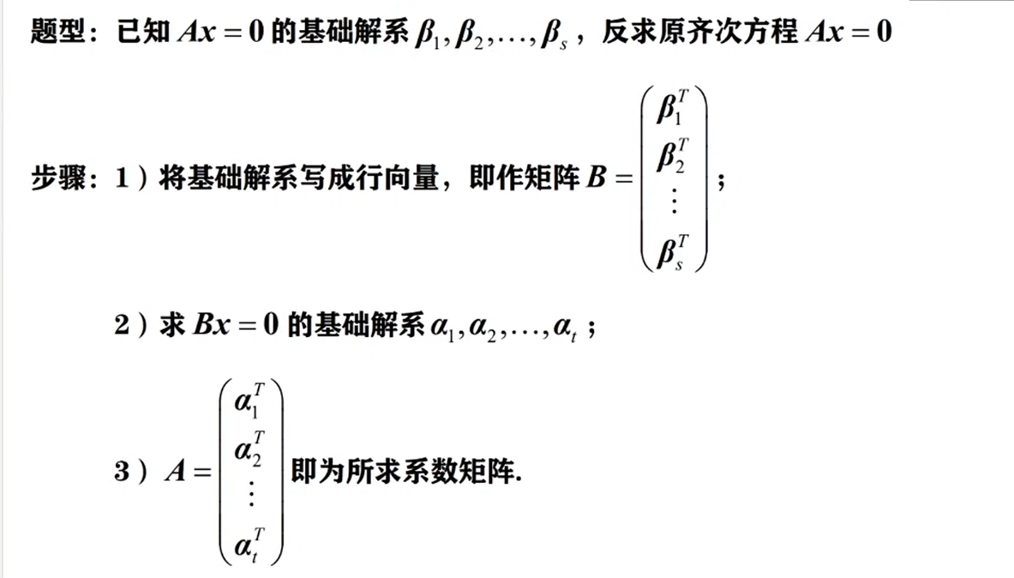
https://chatgpt.com/g/g-p-6a1d6c6f0a408191a175c887909fceb5-xian-dai-he-gai-lu-lun-ocr/c/6a86b9de-c294-83e8-adc4-596c4d52640c

结论：

1：
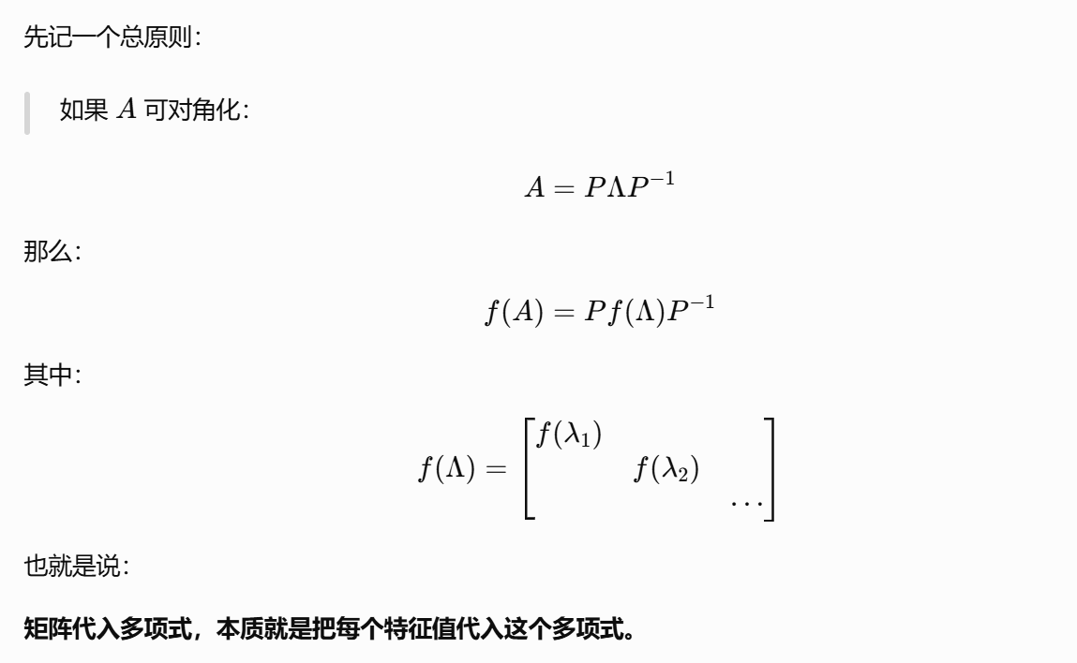

2：
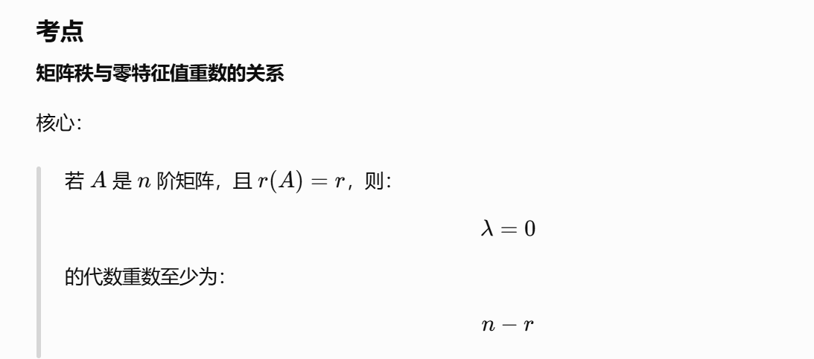
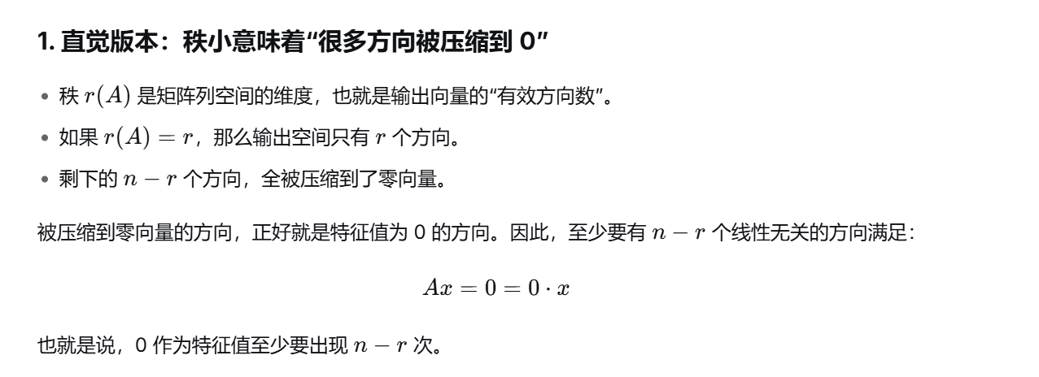
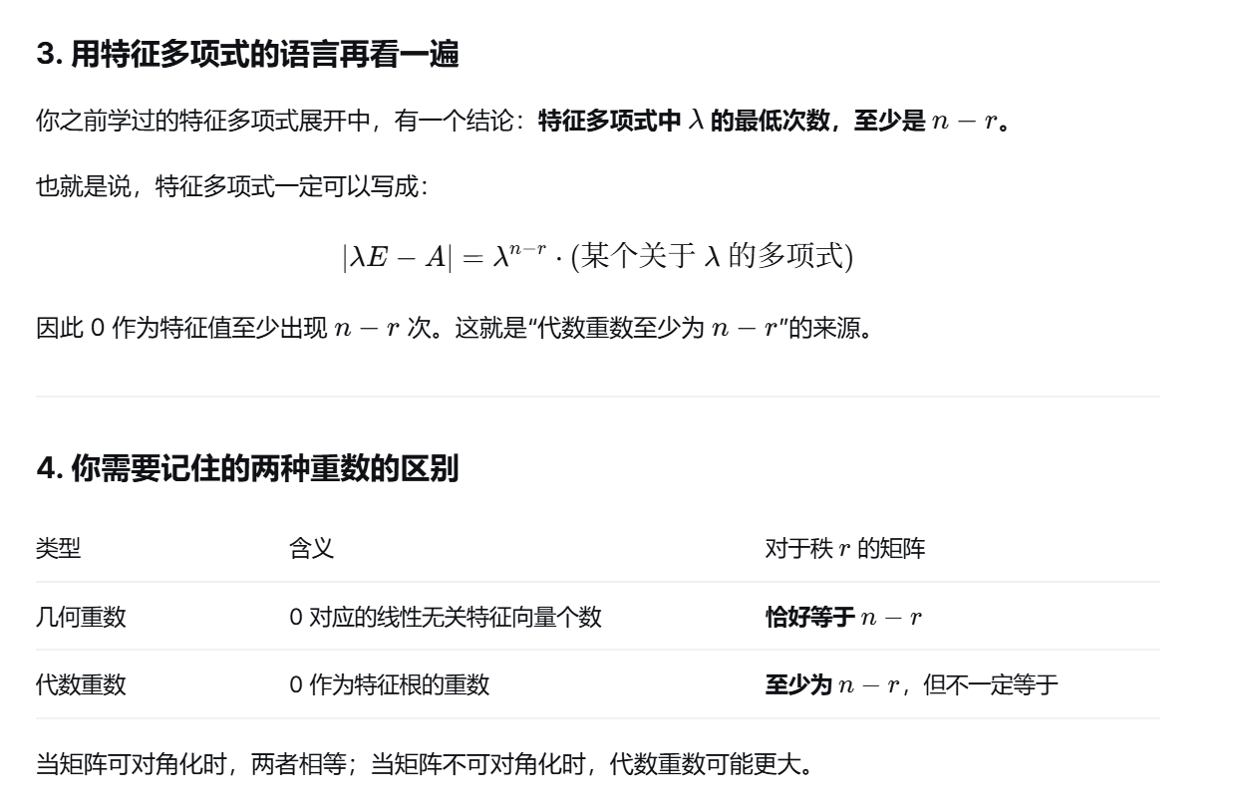

URL:
https://chatgpt.com/g/g-p-6a1d6c6f0a408191a175c887909fceb5-xian-dai-he-gai-lu-lun-ocr/c/6a86ad8d-ca24-83ee-af9b-4743778d15a3?tab=sources

题：

题1：
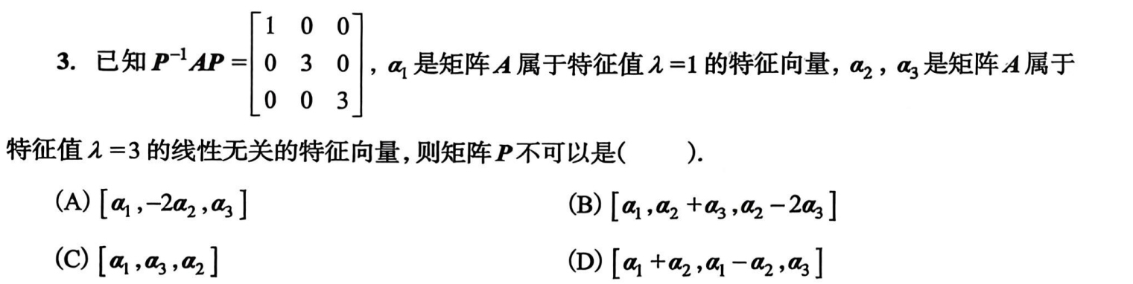
https://chatgpt.com/g/g-p-6a1d6c6f0a408191a175c887909fceb5-xian-dai-he-gai-lu-lun-ocr/c/6a84115a-0194-83ee-824c-58f1cbf701a9

题2：
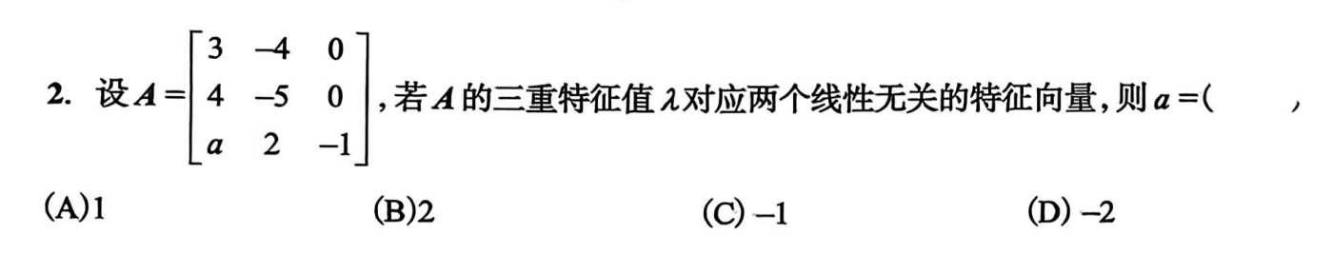
https://chatgpt.com/g/g-p-6a1d6c6f0a408191a175c887909fceb5-xian-dai-he-gai-lu-lun-ocr/c/6a84133c-3b3c-83e9-a4db-f4d24eac8f58

题3：
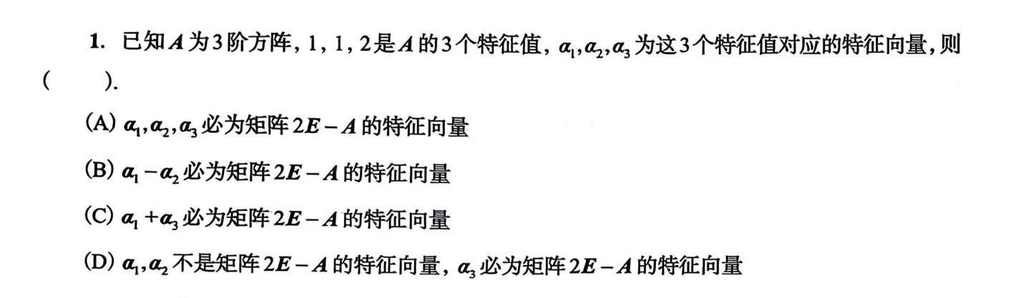
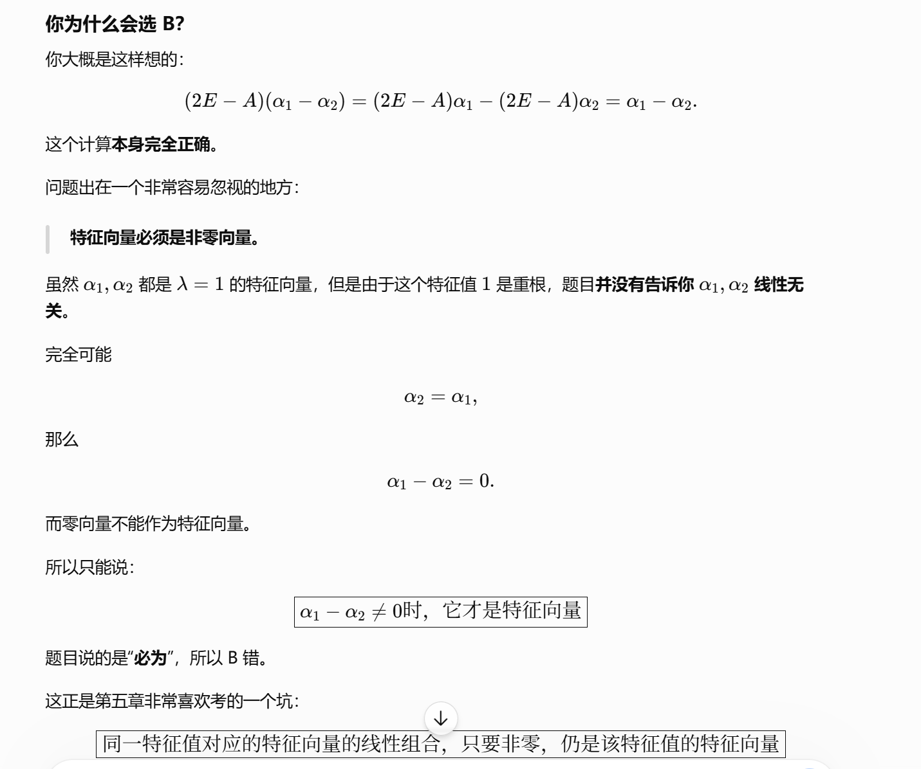

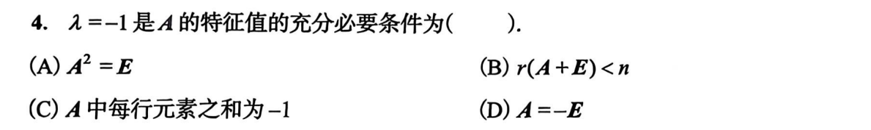
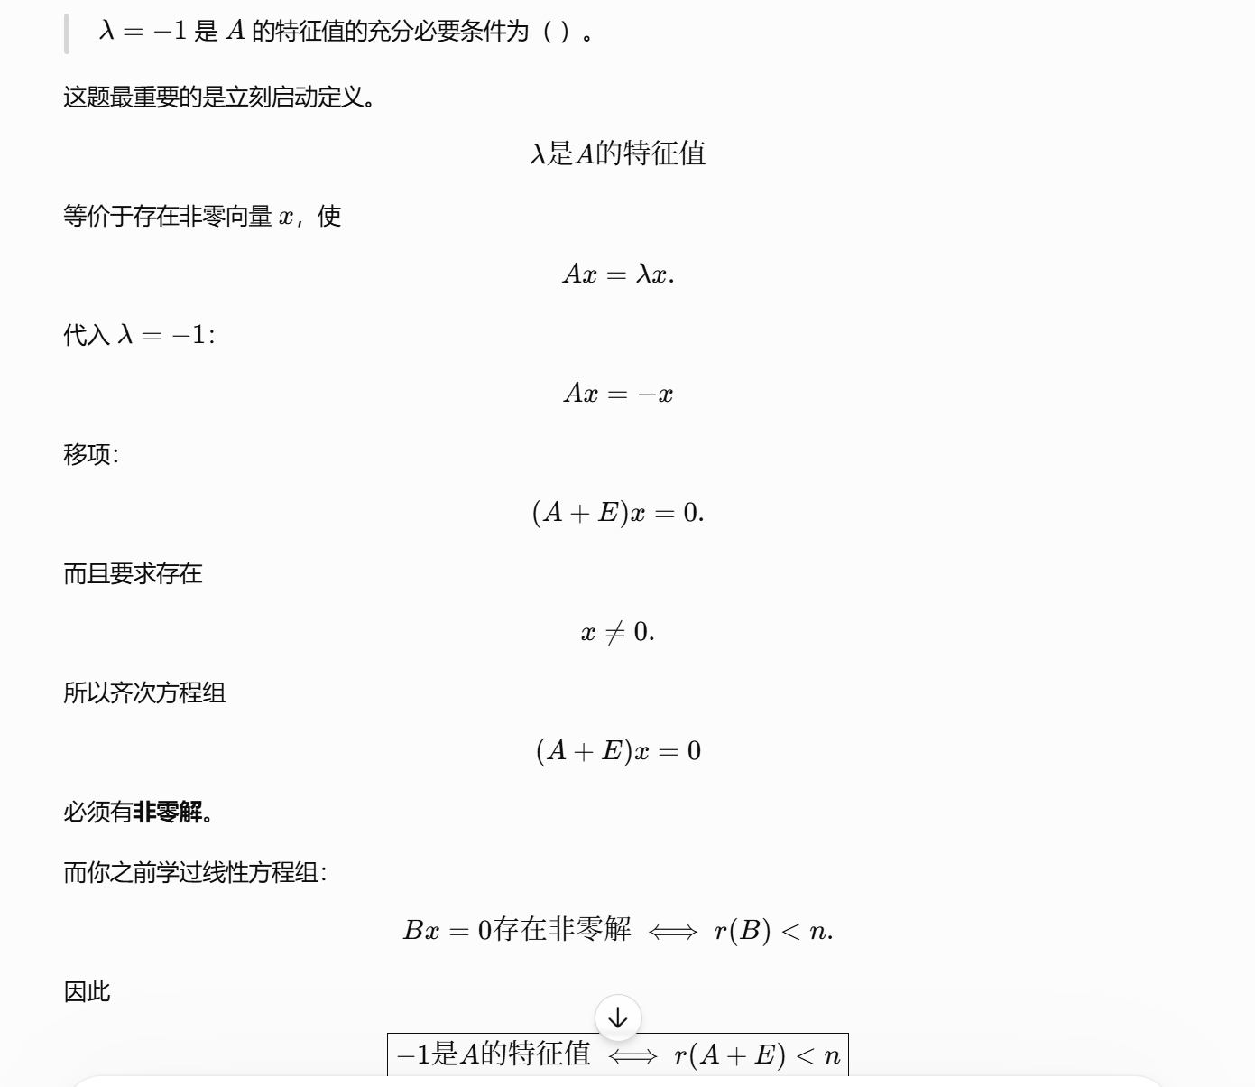
https://chatgpt.com/g/g-p-6a1d6c6f0a408191a175c887909fceb5-xian-dai-he-gai-lu-lun-ocr/c/6a86b2b0-fc78-83e8-ab3f-7e4ada997210

题4：
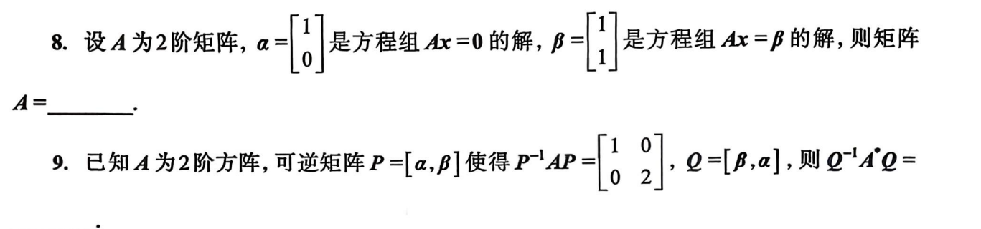
https://chatgpt.com/g/g-p-6a1d6c6f0a408191a175c887909fceb5-xian-dai-he-gai-lu-lun-ocr/c/6a86b400-7fec-83ee-b9ea-f9a5492328ac

题5：
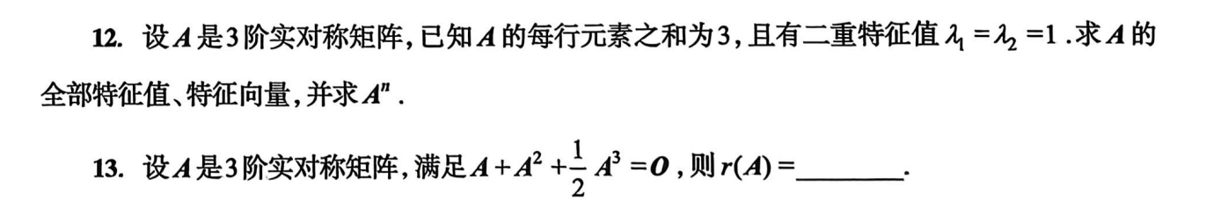
12：https://www.doubao.com/thread/xWwmrKgDsaaysFnyo
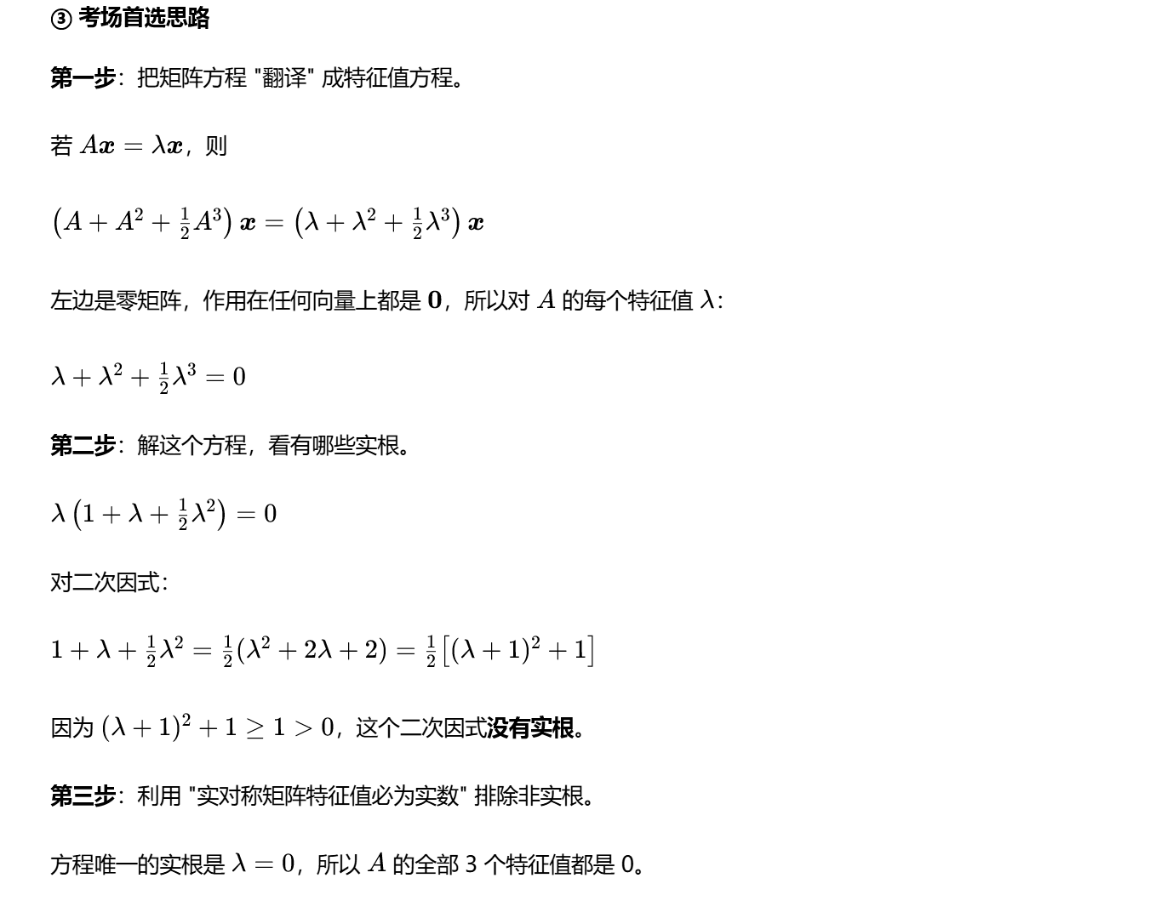
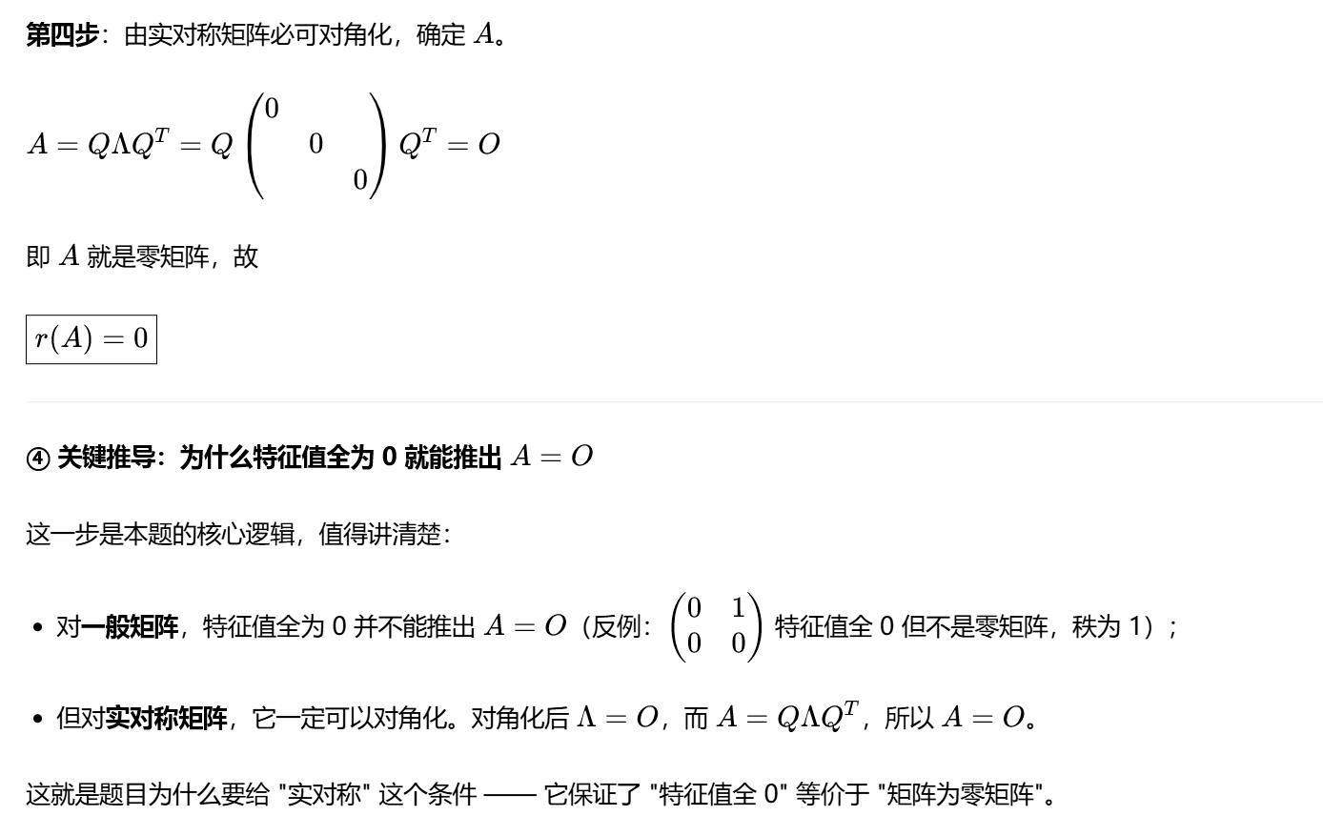
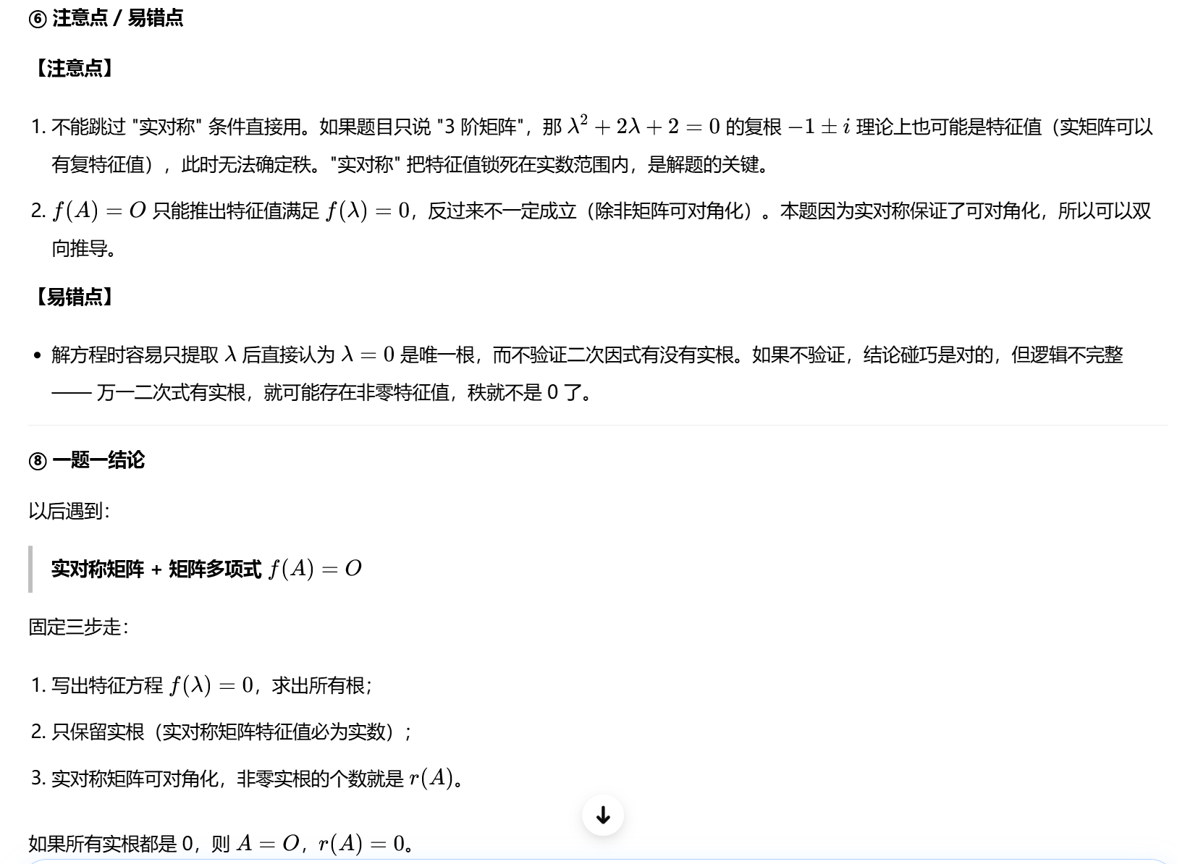
18：
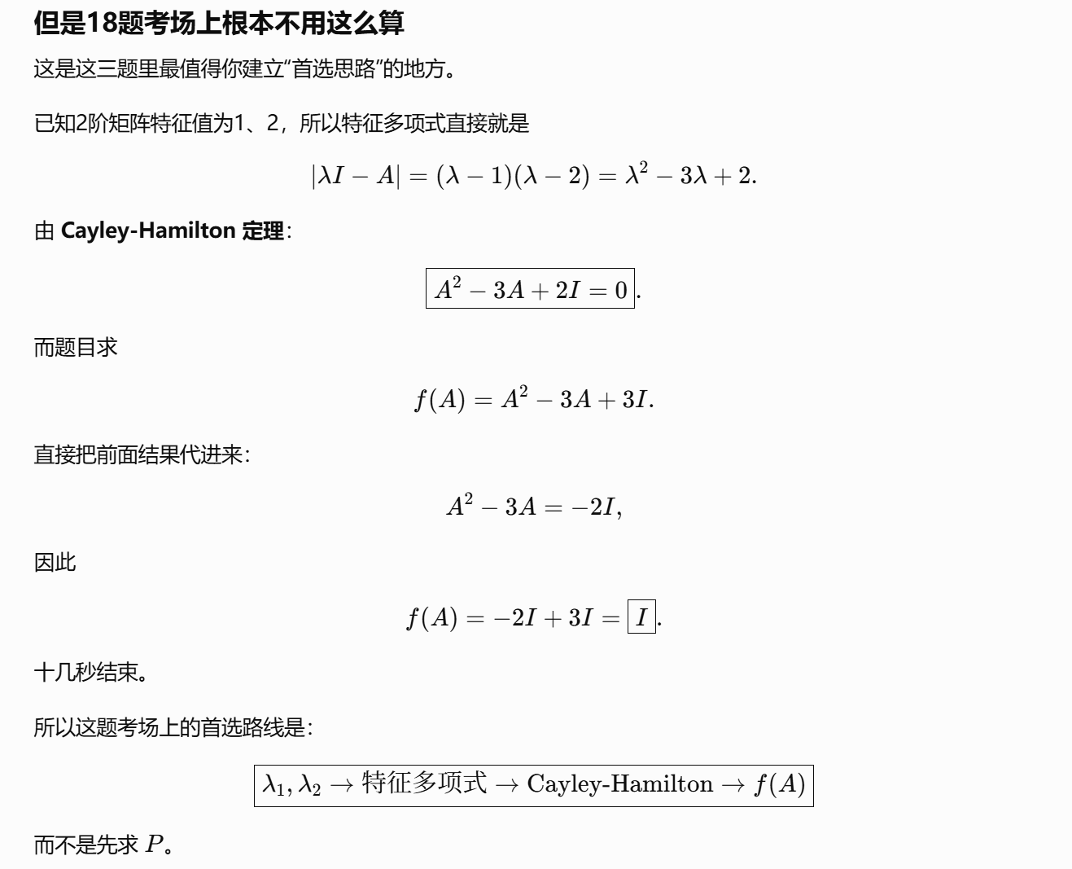
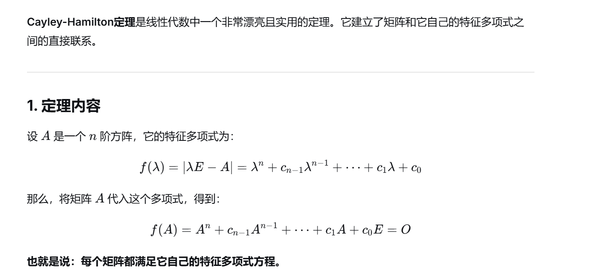
https://chatgpt.com/g/g-p-6a1d6c6f0a408191a175c887909fceb5-xian-dai-he-gai-lu-lun-ocr/c/6a86e973-6fc0-83e8-8391-eb2bf3ebcfcf

题6：
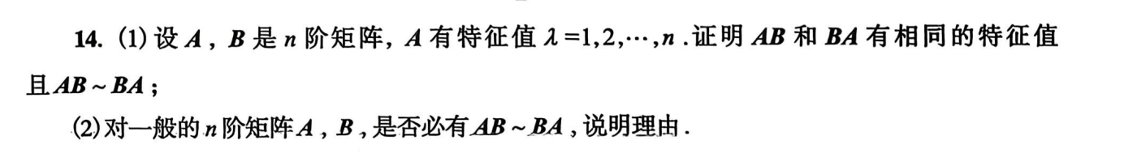
https://chatgpt.com/g/g-p-6a1d6c6f0a408191a175c887909fceb5-xian-dai-he-gai-lu-lun-ocr/c/6a86ed9d-43a8-83e8-a515-541856a0e69d

题7：
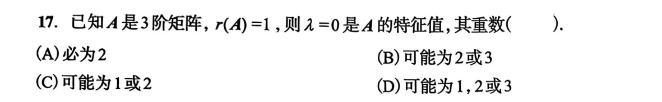
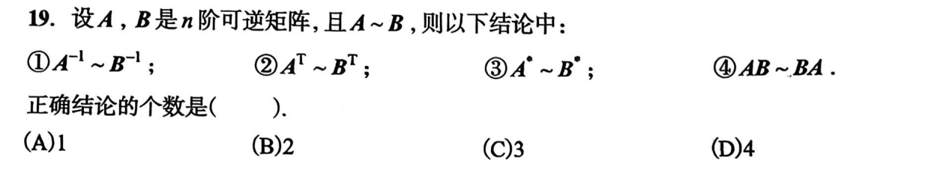
https://chatgpt.com/g/g-p-6a1d6c6f0a408191a175c887909fceb5/c/6a86f0ef-4a68-83ee-9a74-0b0f9ccd405a

题8：
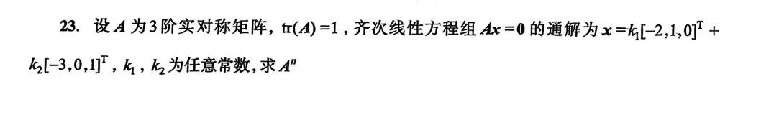
https://chatgpt.com/g/g-p-6a1d6c6f0a408191a175c887909fceb5/c/6a87f856-810c-83e8-ad01-ea053a708efc
|（注：部分内容可能由 AI 生成）

